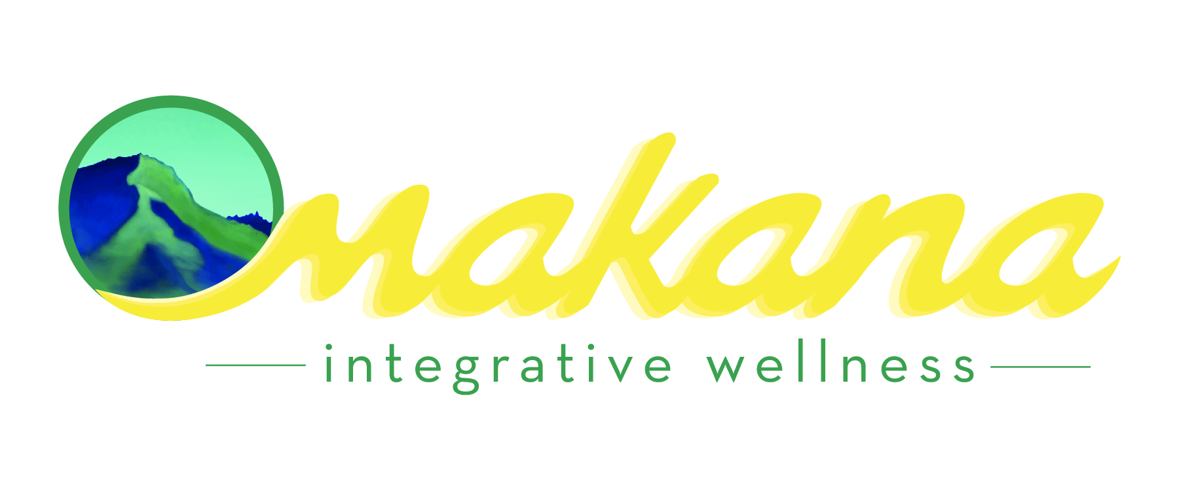
970-224-4145
marina@makanaintegrativewellness.com
LED Light Energy Waiver
Name: _____________________________________________________
Address:____________________________________
City: ___________________________State:_____Zip_______________________
Phone:_____________________________ Email:____________________________________________
Date:__________________________
I, _______________________________, request that Marina Poling, of Makana Integrative Wellness, provides me with LED light energy (Harmonic Light) as an aid to treatment and management of my health. I am fully aware that these LED light energy sessions are designed only to supplement allopathic methods of care, and are not meant to cure and/or replace any medical treatments that I may be receiving.
Marina Poling, QEST™ practitioner, has not suggested that I cease any medical care I am currently receiving, be it drug therapy, surgery, or any other allopathic procedures that my medical doctor deems necessary for my health.
I choose to receive LED light sessions of my own free will and I do not hold Marina Poling responsible for any results that may or may not occur.
By signing below, I acknowledge that I have read and understand all parts of this consent form, that I had the opportunity to ask questions with regard to the described procedures, and I hereby affirm: I am not here for medical diagnostic or treatment procedures and I am here on this and any subsequent visit solely on my own behalf.
Signature:_______________________________________ Date:_______________________
Occupation:__________________________________________________________________
Whom may I thank for your referral?:______________________________________________

